**Python Automation Script Documentation**

**Overview**

This Python automation script is designed to compare schema information between a Snowflake table and a Google Sheet. The script retrieves the schema from Snowflake, fetches corresponding data from a Google Sheet, and generates a comparison report highlighting matches, mismatches, and missing fields. The final report is then written to a new Google Sheet for easy review and analysis.

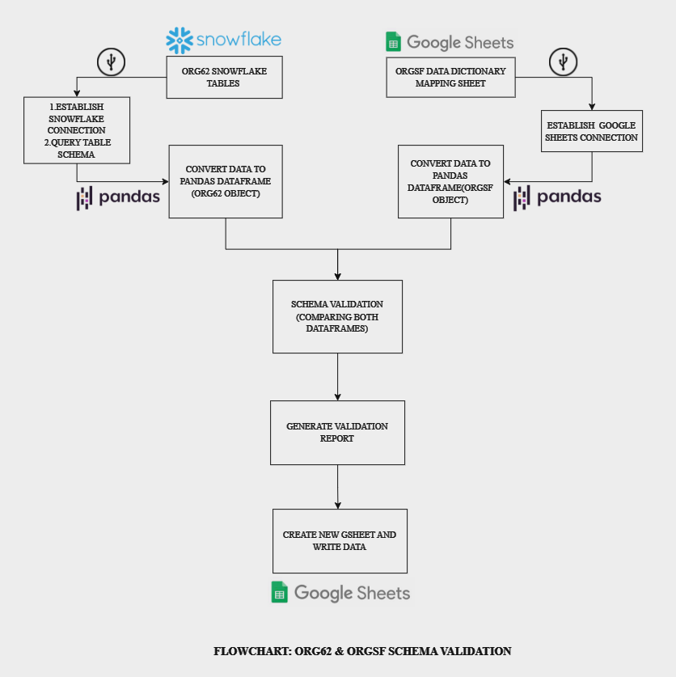

## Strategy Approach

### **Objectives**

• **Automation:** Automate the process of schema comparison to reduce manual effort and minimize errors.

• **Reporting:** Generate detailed comparison reports to identify discrepancies and provide actionable insights.

### **Steps Involved**

1. **Establish Connections:**
   * Connect to Snowflake to retrieve table schema information.
   * Authenticate and connect to Google Sheets to fetch the schema definitions.
2. **Data Retrieval:**
   * Extract schema information from the specified Snowflake table.
   * Retrieve the corresponding schema details from the Google Sheet.
3. **Comparison Logic:**
   * Perform an outer join on the schema data from Snowflake and Google Sheets.
   * Identify matching, mismatched, and missing fields.
4. **Reporting:**
   * Generate a comprehensive comparison report.
   * Write the report to a new Google Sheet in a specified Google Drive folder.

**Scenario’s Covered**

* + **Present in Both:** Fields that are present in both Snowflake and Google Sheets with matching names.
  + **Missing in Snowflake (SF):** Fields that are present in Snowflake but missing in the Google Sheets schema.
  + **Missing in Org62:** Fields that are present in the Google Sheets schema but missing in Snowflake.
  + **Renamed in OrgSF:** Fields that are not matching but have been renamed in the Google Sheets schema. If a matching entry is found in the mapping sheet, it is considered a renamed field.
  + **Not Matched:** Fields that do not match in both Snowflake and Google Sheets are checked against a data mapping sheet. If a matching entry is not found in the mapping sheet, it is considered a not matched field.

**Final Output Snapshot:**

